**Experiment No: 12**

**Title:** Cloud Computing and Infrastructure mini-project AWS S3 bucket and EC2

**Aim:** To deploy an web application on AWS cloud

**Theory :**

1. **EC2 :**

Amazon Elastic Compute Cloud (EC2) is a web service that provides resizeable compute capacity in the cloud. It allows you to run virtual servers known as instances, which can host various applications and services. EC2 is a fundamental building block of Amazon Web Services (AWS), and it offers numerous benefits for engineering students and professionals.

**Key Concepts and Features:**

**Instances**: These are the virtual servers you can launch in EC2. You can choose from a wide range of instance types, each optimized for different workloads, including general-purpose, compute-optimized, memory-optimized, and more.

**Amazon Machine Images (AMIs)**: AMIs are templates that contain information about the software, configurations, and launch permissions needed to create an instance. AWS provides a variety of pre-configured AMIs, and you can also create your custom AMIs.

**Security Groups**: These act as virtual firewalls for your instances. You can define inbound and outbound traffic rules to control network access to your instances.

**Elastic Block Store (EBS)**: EBS provides block-level storage volumes that can be attached to your EC2 instances. It's used for data storage and is essential for maintaining data durability.

**Regions and Availability Zones**: AWS has a global network of data centers, organized into regions and availability zones. You can choose the region and availability zone to host your instances, considering factors like latency, data residency, and fault tolerance.

**Auto Scaling:** This feature allows you to automatically adjust the number of instances in response to changes in demand. It's crucial for maintaining performance and cost efficiency.

**Load Balancers:** Elastic Load Balancing (ELB) distributes incoming traffic across multiple instances to ensure high availability and fault tolerance.

**Identity and Access Management (IAM):** You can manage access to your EC2 resources using IAM, defining permissions and roles for users and services.

1. **S3 Bucket :**

Amazon Simple Storage Service (S3) is an object storage service that offers industry-leading scalability, data availability, security, and performance. It's designed to store and retrieve any amount of data from anywhere on the web. S3 is commonly used for data storage, backup, and as a central repository for various applications.

**Key Concepts and Features:**

**Buckets**: In Amazon S3, data is stored in containers called buckets. Each bucket has a globally unique name and can store an unlimited number of objects.

**Objects**: Objects are the basic storage entities in S3. They consist of data, a unique key (or identifier), and metadata. Objects can be files, images, documents, or any other data types.

**Data Consistency**: Amazon S3 provides strong read-after-write consistency for all objects stored in S3. This ensures that when you write a new object or update an existing one, the most recent data is returned when read.

**Data Durability**: S3 is designed to provide 99.999999999% (11 nines) durability. This means that your data is highly reliable and durable.

**Storage Classes**: S3 offers various storage classes to optimize costs based on access patterns and retention policies. These include Standard, Intelligent-Tiering, Glacier, and more.

**Versioning**: S3 supports versioning, allowing you to preserve, retrieve, and restore every version of every object stored in a bucket.

**Lifecycle Policies**: You can define rules to automatically transition objects between storage classes, delete them when they're no longer needed, or archive them to Glacier.

**Access Control**: Amazon S3 provides fine-grained access control using bucket policies, Access Control Lists (ACLs), and Identity and Access Management (IAM) roles.

**Use Cases:**

**Data Backup and Recovery**: S3 is commonly used for backing up critical data, and it's a part of many disaster recovery strategies.

**Static Website Hosting**: You can host static websites directly from an S3 bucket, using S3 to serve HTML, CSS, JavaScript, and other web assets.

**Data Archiving**: Glacier, a part of S3, is suitable for long-term data archiving and compliance requirements.

**Big Data Analytics**: S3 is often used as a data lake for storing and analyzing vast amounts of structured and unstructured data.

**Content Distribution**: Amazon S3 can be integrated with Amazon CloudFront to distribute content globally with low latency.

**Steps :**

1. **Create your web application and compress it.**
2. **Add To S3 bucket**

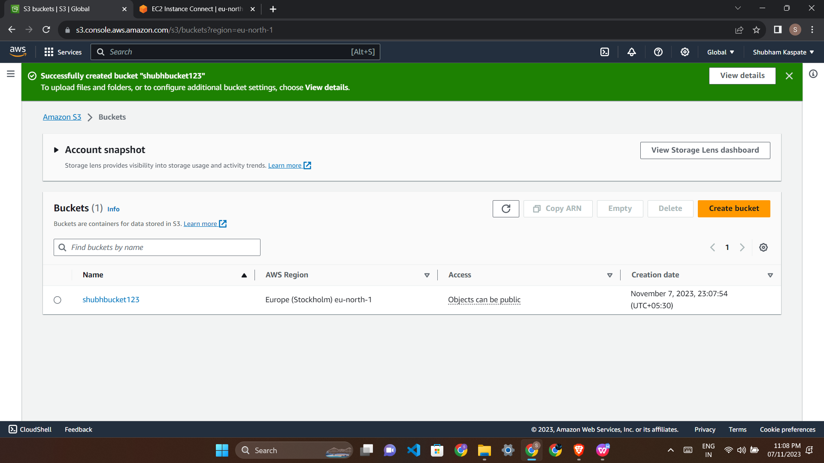

1. **Create EC2 Instance**

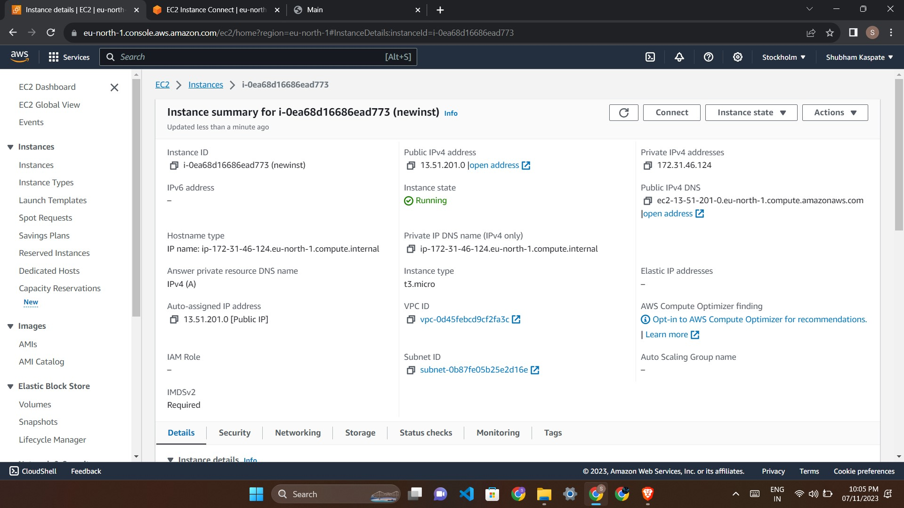

1. **Install Apache**

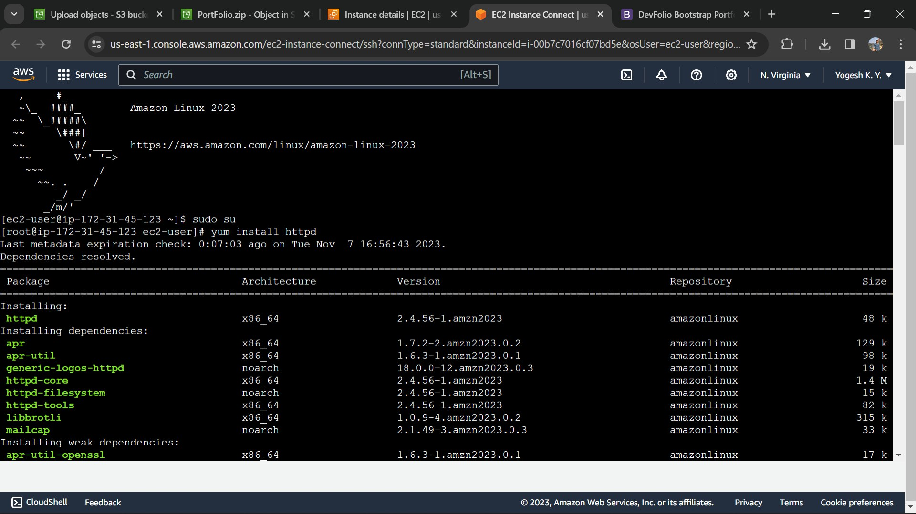

1. **Upload the file**
2. **Load the project**

**Conclusion:**

Thus, I have created a mini project using AWS s3 bucket, EC2-Linux instance.